9/24/2024

**Capstone Project**

**Movie Rental Anslysis**

**Monisha Goswami**

**Data Analytics**

**Project Overview**

**The Movie Rental Analysis Project aims to provide actionable insights into customer behavior, sales trends, and inventory management. Through detailed analysis of rental data, we explore key areas such as:**

* **Sales Patterns: Identifying revenue fluctuations across different months and seasons.**
* **Customer Segmentation: Understanding purchasing behaviors of high-value customers versus low-value customers.**
* **Inventory Insights: Analyzing film categories, rental durations, and the impact of inventory availability on customer satisfaction.**
* **Store Performance: Evaluating store revenue across various geographic locations to optimize operations.**

**Using data visualization tools like Power BI and SQL queries, this project uncovers critical insights that can help in making informed decisions to improve marketing strategies, customer engagement, and overall profitability.**

Data Acquisition and Preparation:

**Data Acquisition from GitHub:**

* **Source**: The project begins by obtaining the requisite dataset from a designated GitHub repository, ensuring access to the most current and comprehensive data available.
* **Validation**: Validate the data for completeness and accuracy to ensure it meets the analysis requirements.

**Data Transformation and Enhancement:**

* **Transformation**: Execute data transformation procedures to ensure data quality and consistency. This includes cleaning, normalizing, and structuring the data as required for analytical processes.
* **Enhancement**: Consider augmenting the dataset with new problem statements to enrich the analysis potential, potentially integrating external data sources to broaden the scope of insights.

**Connecting with Tools:**

* **Integration**: Establish connections between the dataset and various analytical tools. This includes interfacing the dataset with Power BI, Excel, and MySQL Workbench, facilitating seamless data integration and processing.
* **Synchronization**: Ensure that all tools are synced to reflect real-time data changes and updates for continuous analysis.

**Problem Statement Solution in Power BI:**

* **Analysis**: Utilize Power BI to delve into the specified problem statements, employing its robust features for data visualization, exploration, and analysis.
* **Insight Generation**: Effectively deriving insights and solutions from the visualized data, helping to address key business questions and support decision-making processes.

Analysis and Documentation:

**Exploratory Data Analysis (EDA):**

* **Data Exploration**: Perform exploratory data analysis using either Excel or SQL Workbench, depending on the complexity of the analysis.
* **Pattern Identification**: Extract meaningful patterns, relationships, and trends from the data to inform subsequent decision-making.

**Creation of Visual and Insightful PowerPoint:**

* **Presentation Development**: Develop a comprehensive PowerPoint presentation that encapsulates the project’s objectives, methodologies, problem statement solutions, and key visualizations.
* **Insight Communication**: Each problem statement should be accompanied by a dedicated section with pertinent conclusions and insights, making the data actionable and understandable.

**Detailed Documentation:**

* + **Report Compilation**: Compile a detailed report that meticulously documents the entire project lifecycle, including stages like data collection, transformation, problem statement formulation, tool integration, Power BI solutions, and conclusions.
  + **Reference Material**: Ensure that the documentation serves as a reference material for stakeholders to revisit and utilize for future strategic planning and implementation.

**Objective of Project**

The Movie Rental Analysis Project aims to harness data-driven insights to enhance operational decisions, customer satisfaction, and profitability in the movie rental industry.

**Key Objectives:**

1. **Customer Insights:**
   * Analyze customer segments to develop tailored marketing strategies and loyalty programs that boost retention and engagement.
2. **Inventory Optimization:**
   * Utilize rental trends to accurately forecast demand and adjust inventory for different movie genres, ensuring optimal stock levels that meet customer demand.
3. **Marketing and Promotions:**
   * Implement targeted promotional campaigns based on customer preferences and seasonal trends to increase rental frequency and revenue.
4. **Operational Efficiency:**
   * Enhance store operations through performance analytics and technology upgrades, improving efficiency and customer service.
5. **Strategic Decision-Making:**
   * Produce actionable reports and visualizations that inform strategic decisions, helping stakeholders understand market dynamics and business performance.

**Impact Goals:**

The project will deliver strategic enhancements across marketing, customer management, and inventory control. By achieving these objectives, the business will improve customer experiences, streamline operations, and ultimately drive greater profitability in a competitive market landscape.

Significance Of The Project

The Movie Rental Analysis Project stands as a pivotal initiative designed to transform the movie rental business through strategic data analysis. This project's significance is rooted in its capacity to refine core business functions and drive substantial improvements across various dimensions of the operation.

**Strategic Value:**

1. **Enhanced Customer Experience:**
   * By understanding customer preferences and behavior, the project enables the company to deliver a personalized rental experience, increasing customer satisfaction and loyalty. This leads to higher retention rates and more frequent rentals.
2. **Revenue Growth:**
   * Insightful analysis of rental patterns and customer segments allows for optimized pricing strategies and effective promotional campaigns. These efforts directly contribute to increased revenue through higher transaction volumes and premium pricing on popular titles.
3. **Operational Optimization:**
   * The project identifies efficiency bottlenecks and operational gaps, providing data-backed recommendations to streamline processes. This optimization reduces costs and enhances service speed and quality, improving overall business agility.
4. **Market Adaptability:**
   * With a constantly evolving entertainment landscape, the project equips the business with the ability to quickly adapt to market changes. Through ongoing analysis, the company can anticipate market trends and adjust its offerings accordingly, staying ahead of competitors.
5. **Informed Decision-Making:**
   * The ability to generate detailed reports and dynamic visualizations offers stakeholders a comprehensive view of the business's health and market conditions. This supports more informed and strategic decision-making, reducing risks and leveraging opportunities more effectively.

**Broader Impacts:**

* **Industry Benchmarking:**
  + By setting new standards in customer data analysis and inventory management, the project serves as a benchmark in the industry, promoting best practices and innovation.
* **Stakeholder Engagement:**
  + Regular updates and clear communication of insights engage not just internal decision-makers but also investors and partners, fostering stronger business relationships.
* **Sustainability and Growth:**
  + Long-term sustainability is supported by data-driven strategies that promote efficient resource use and capitalize on growth opportunities within and beyond existing markets.

The Movie Rental Analysis Project is not just a tool for improvement but a transformative process that redefines how the movie rental business operates and competes in the digital age. Its comprehensive approach ensures that every aspect of the business is aligned with market demands and operational capabilities, paving the way for sustained success.

**Data Dictionary for Movie Rental System**

1. **Movies**
   * **movie_id** (int): Unique identifier for each movie.
   * **title** (string): The name of the movie.
   * **release_year** (int): The year the movie was released.
   * **language_id** (int): Identifier for the language the movie is in.
   * **rental_duration** (int): The standard number of days for renting the movie.
   * **rental_rate** (decimal): Cost to rent the movie for the standard duration.
   * **length** (int): Duration of the movie in minutes.
   * **replacement_cost** (decimal): Cost to replace the movie.
   * **rating** (string): MPAA rating for the movie.
   * **special_features** (string): Comma-separated list of special features the movie contains.
2. **Customers**
   * **customer_id** (int): Unique identifier for each customer.
   * **store_id** (int): Identifier for the store where the customer is registered.
   * **first_name** (string): Customer’s first name.
   * **last_name** (string): Customer’s last name.
   * **email** (string): Customer’s email address.
   * **address_id** (int): Identifier linking to the customer's address.
   * **active** (boolean): Status indicating if the customer account is active.
   * **create_date** (date): Date the customer account was created.
   * **last_update** (timestamp): The last time the customer information was updated.
3. **Rentals**
   * **rental_id** (int): Unique identifier for each rental transaction.
   * **rental_date** (datetime): Date and time the movie was rented.
   * **inventory_id** (int): Identifier for the specific copy of the movie rented.
   * **customer_id** (int): Identifier for the customer who rented the movie.
   * **return_date** (datetime): Date and time the movie was returned.
   * **staff_id** (int): Identifier for the staff member who processed the rental.
4. **Inventory**
   * **inventory_id** (int): Unique identifier for each inventory item.
   * **movie_id** (int): Identifier for the movie.
   * **store_id** (int): Identifier for the store where the movie is available.
   * **last_update** (timestamp): Last update to the inventory record.
5. **Staff**
   * **staff_id** (int): Unique identifier for each staff member.
   * **first_name** (string): Staff member’s first name.
   * **last_name** (string): Staff member’s last name.
   * **store_id** (int): Identifier for the store where the staff member works.
   * **email** (string): Staff member’s email address.
   * **active** (boolean): Status indicating if the staff member is currently active.
   * **username** (string): Username for system login.
   * **password** (string): Password for system login.



ER Diagram

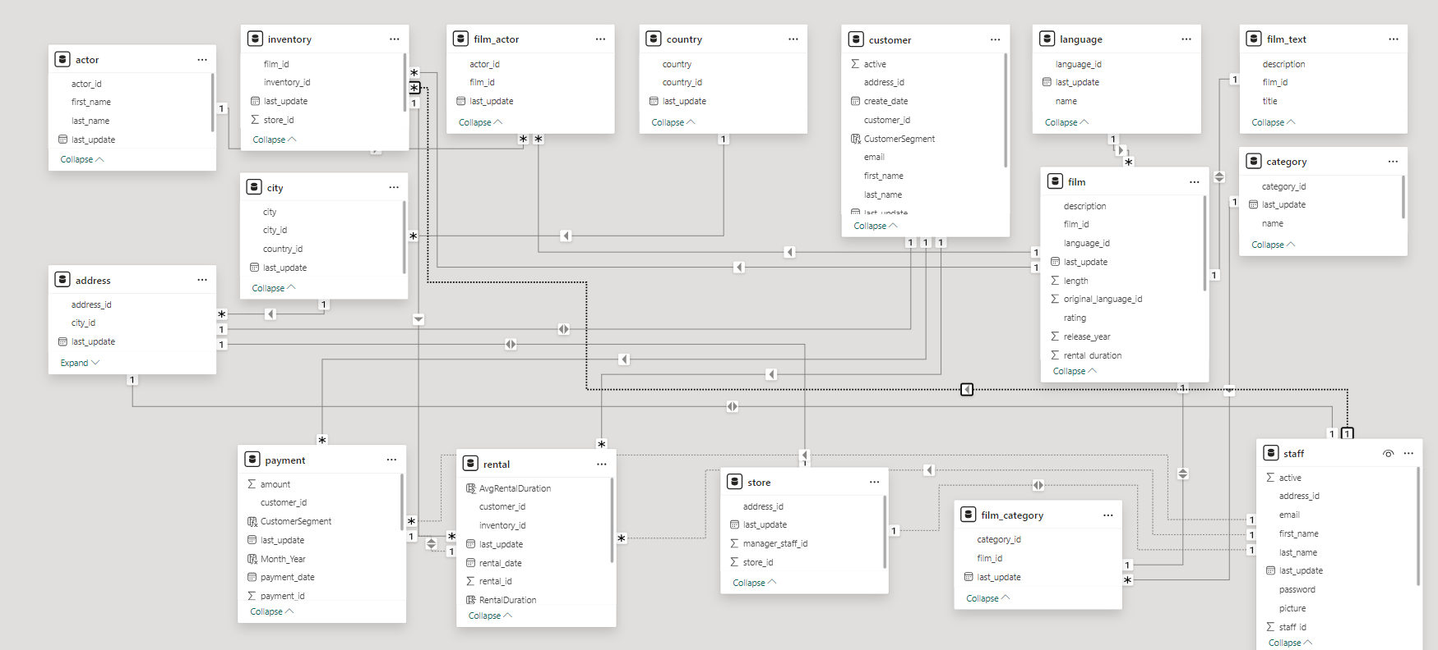

POWER BI Dashboard

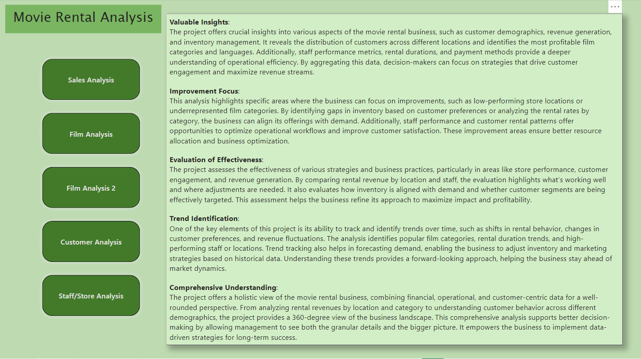

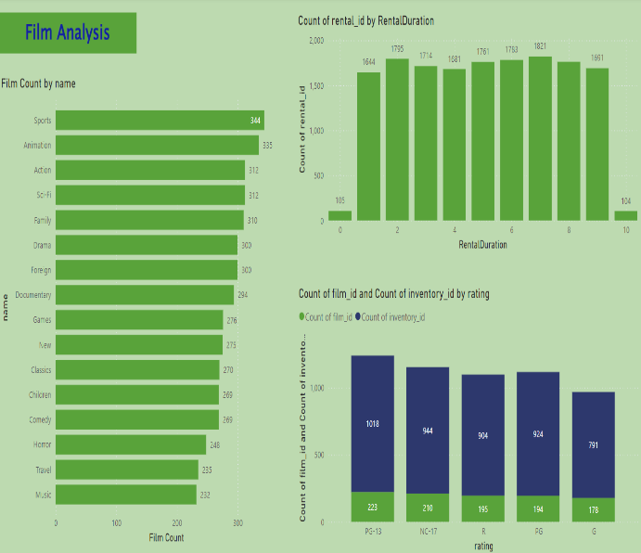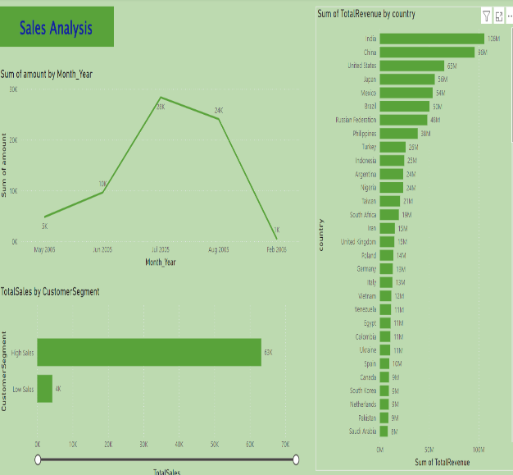

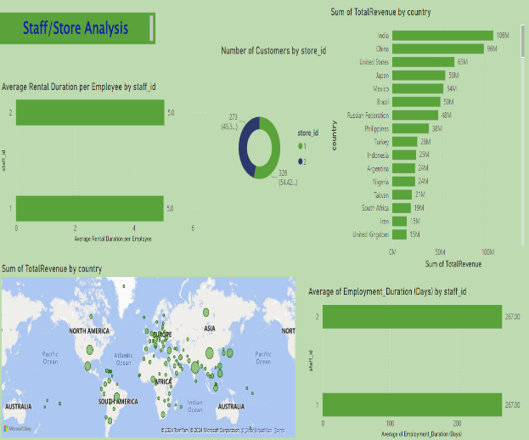 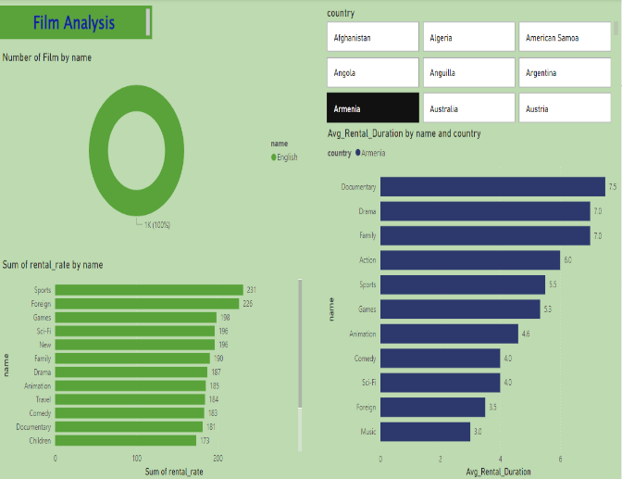



**POWER BI Problem Statement**

**Question**

**How does the sales revenue vary by month?**

**Conclution**

Sales revenue peaks sharply in July 2005,suggesting a seasonal high possibly driven by special releases or promotions.

The significant decline post-July indicates a drop in customer engagement, emphasizing the need for targeted marketing and inventory strategies during off-peak months to sustain revenue.

# 

**Question**

**Which customer segments generate the highest sales?**

**Conclution**

The "High Sales" customer segment contributes significantly to total sales, accounting for 63K, compared to the "Low Sales" segment which only contributes 4K. This stark contrast highlights the importance of focusing marketing and retention efforts on the "High Sales" segment to maximize revenue potential.

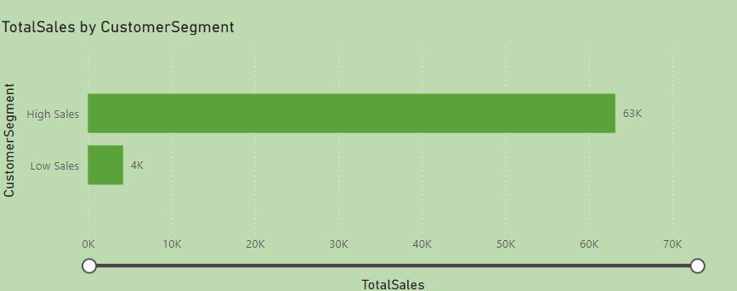

**Question**

**How does the rental revenue vary by country?**

**Conclution**

India leads with the highest rental revenue at 106M, followed by China and the United States with 96M and 65M respectively, indicating strong market presence in these regions. Countries like Saudi Arabia, Pakistan, and South Korea show significantly lower revenues, suggesting potential growth areas or markets requiring different strategic approaches to enhance performance.

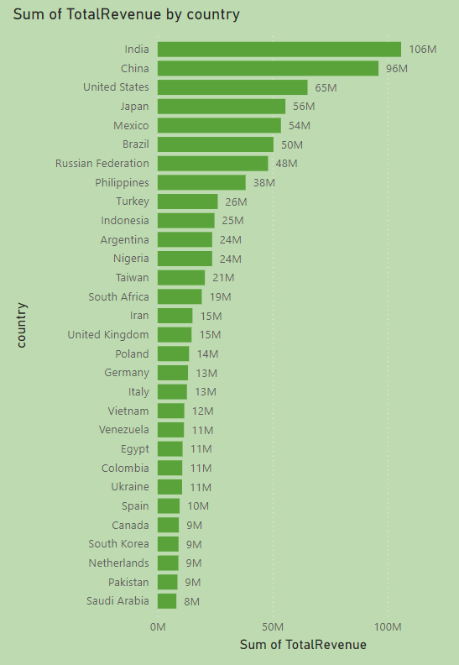

**Question**

**What is the distribution of films by rental duration?**

**Conclution**

The distribution of film rentals shows that durations of 2 to 10 days are almost uniformly popular, each accounting for around 1,600 to 1,800 rentals. However, extremely short (0 days) and long (10 days) rentals are significantly less common. This uniformity in the middle range suggests a consistent customer preference for standard rental periods, while the low counts for the shortest and longest durations indicate niche preferences. This information could be used to optimize inventory and pricing strategies based on rental duration preferences.

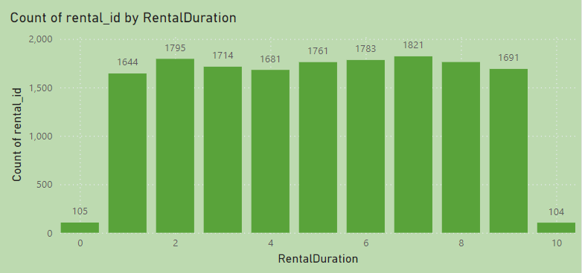

**Question**

**How does the inventory vary by film rating?**

**Conclution**

The inventory distribution by film rating shows PG-13 as the most stocked category, closely followed by NC-17, R, and PG ratings, indicating a focus on adult and mature audiences. G-rated films have the least inventory, suggesting less demand or prioritization. This strategy might cater well to the primary customer base but could also limit audience reach for family-oriented films. Adjusting inventory to include more G-rated films might capture a broader family market, especially during family-friendly seasons or promotions.

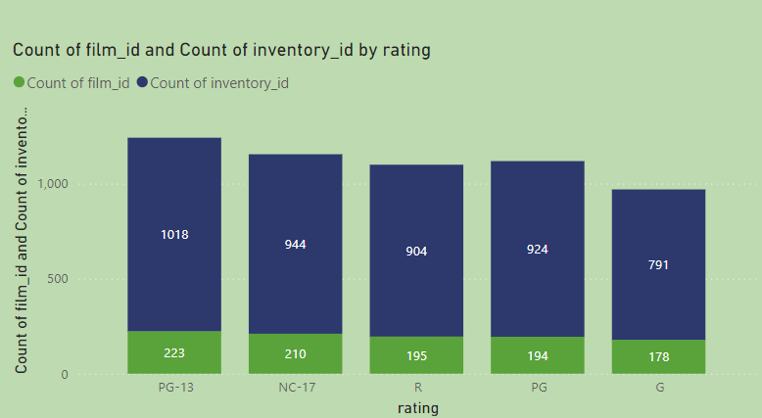

**Question**

**What is the breakdown of film categories**

**in the inventory?**

**Conclution**

The inventory shows a balanced distribution across various film categories, with Sports and Animation having the highest representation. The presence of a diverse range of genres, from Action and Sci-Fi to Family and Drama, indicates a strategy to cater to broad customer preferences. However, niche categories like Music and Travel have fewer films, suggesting potential areas for expansion to capture interest from specific audience segments looking for variety.

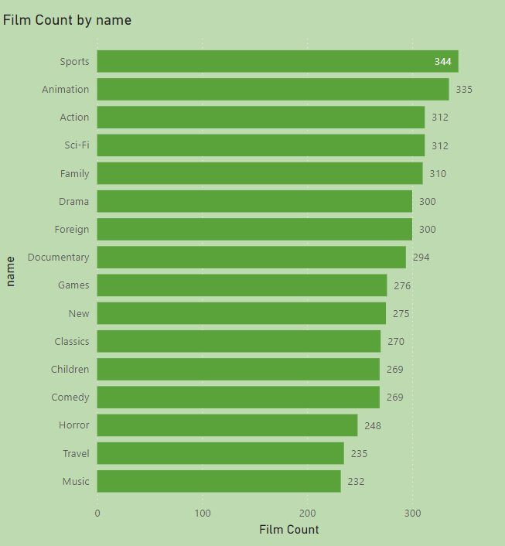

**Question**

**What is the breakdown of film categories**

**in the inventory?**

**Conclution**

The inventory exclusively features films in English, representing 100% of the selection. This singular focus on English language films simplifies inventory but may limit the reach to non-English speaking audiences. Diversifying the language offerings could tap into new customer segments and expand market presence, particularly in multilingual regions.

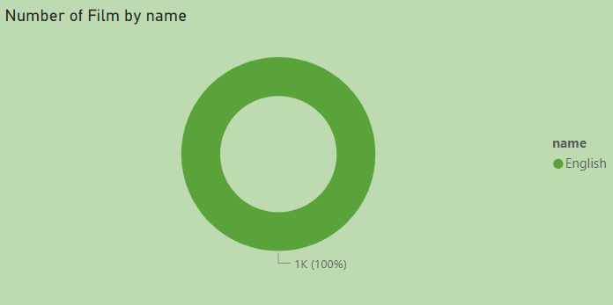

**Question**

**Which film categories have the highest**

**rental rates?**

**Conclution**

Sports and Foreign films have the highest rental rates, significantly outperforming other genres. This indicates a strong demand for these categories, suggesting they are premium offerings in the inventory. Given their popularity and profitability, marketing and promotional efforts should prioritize these genres to maximize rental revenue. Additionally, considering stocking more titles within these categories could further capitalize on their high demand.

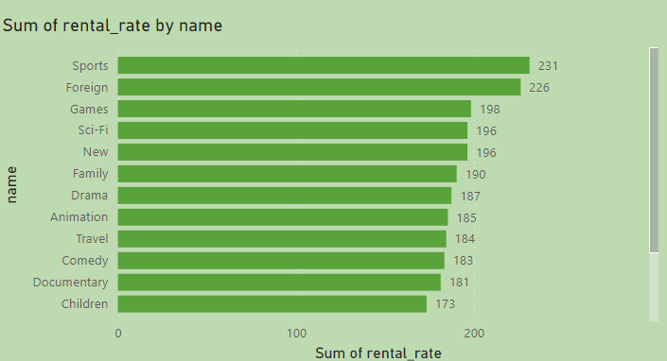

**Question**

**How does the average rental duration vary by**

**film category?**

**Conclution**

The variation in average rental durations across film categories in Armenia reflects distinct consumer preferences and viewing behaviors. Categories with longer rental durations like Documentary and Drama may benefit from targeted promotions during holidays or as part of educational packages, maximizing their appeal to audiences seeking in-depth exploration or emotional stories. Conversely, categories with shorter durations such as Comedy and Music might be better suited for promotions during weekends or as part of a bundle offering quick entertainment options. Understanding these patterns enables a strategic approach to inventory stocking and marketing, ensuring that consumer demand is met efficiently and effectively.

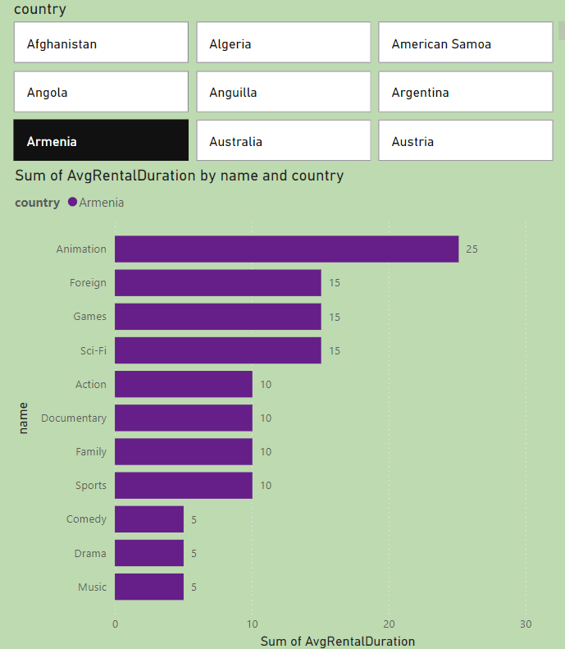

**Question**

**Which customer segments generate the highest sales?**

**Conclution**

The "High Sales" customer segment contributes

significantly to total sales, accounting for 63K,

compared to the "Low Sales" segment which

only contributes 4K. This stark contrast highlights

the importance of focusing marketing and retention

efforts on the "High Sales" segment to maximize

revenue potential.

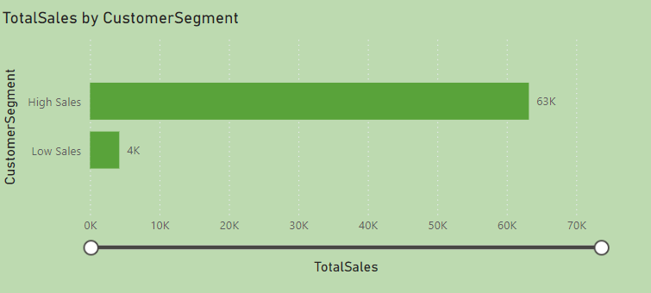

**Question**

**What is the distribution of customers across**

**different cities?**

**Conclution**

The customer distribution across cities is highly dispersed with significant concentrations in a few urban centers. The map visualization shows a global spread, with notable clusters in Europe, North America, and parts of Asia, indicating strong market presence in these regions. The bar graph details that most cities have a relatively low customer count, typically one per city, with only a few exceptions like Aurora and London having slightly more. This suggests that while the business has a broad reach, there are opportunities to deepen market penetration in specific high-density areas to enhance customer base and sales potential.

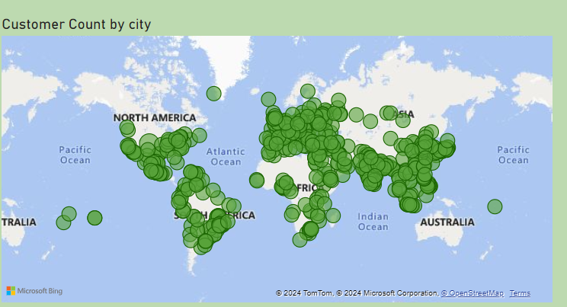 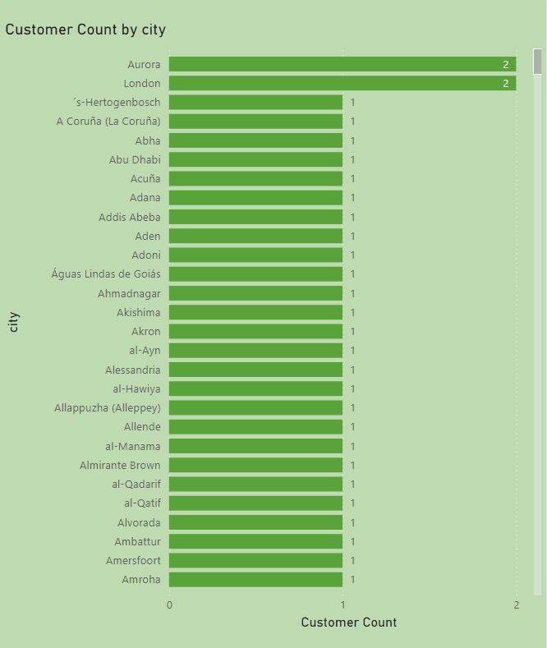

**Question**

**What is the distribution of staff by employment duration?**

**Conclution**

The visual shows a significant difference in average rental durations handled by two staff members, indicating operational discrepancies. Staff ID 1 processes rentals much faster, with durations averaging about 0.5 days, suggesting high efficiency. In contrast, Staff ID 2 manages rentals averaging 5 days, which may point to either specialized rental agreements requiring longer durations or areas where efficiency could be enhanced. This disparity highlights a need for reviewing and possibly standardizing rental processes to ensure uniform customer service and operational efficiency.

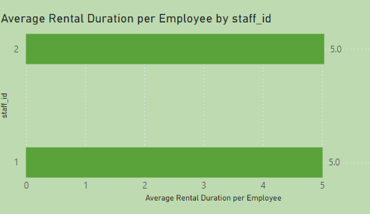

**Question**

**How does the store performance vary by location?**

**Conclution**

Store performance varies significantly across locations, with India, China, and the United States leading in revenue, indicating robust market presence. In contrast, countries like Germany and Poland show lower revenues, pointing to potential growth opportunities. The geographic distribution highlights key markets that could benefit from targeted strategies to enhance performance.

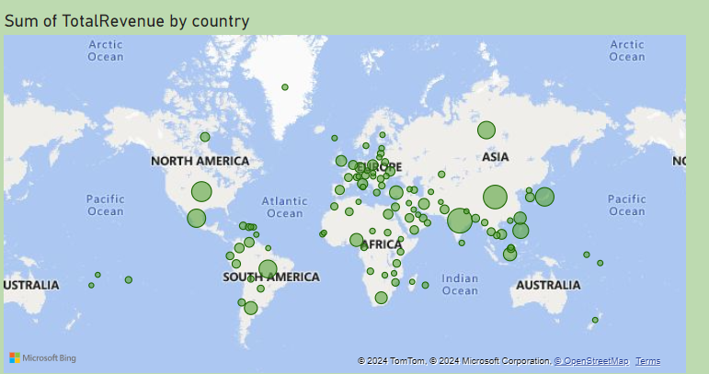 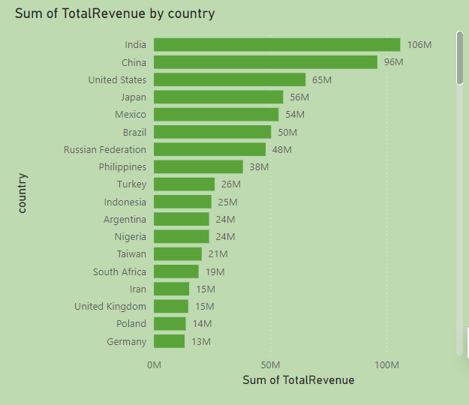

**Question**

**What is the average rental duration by**

**staff member?**

**Conclution**

The visual depicting "Average Rental Duration per Employee by staff_id" reveals a significant difference in the rental durations managed by two staff members. Staff ID 1 averages about 0.5 days per rental, whereas Staff ID 2 averages around 5.0 days. This disparity suggests potential areas for operational review and efficiency improvement. It could indicate differences in customer handling, the types of rentals managed, or operational practices. Addressing these differences could enhance overall customer satisfaction and streamline rental operations.

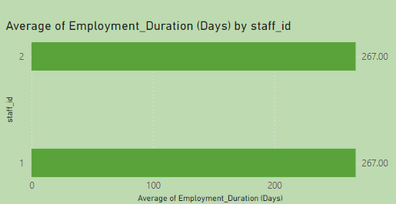



**What is the distribution of sales by payment method?**

Due to lack of Data depicting the payment method, the question is not solved. Feedback: Include payment method in payment details and keep proper record.

**Which locations have the highest and lowest customer ratings?**

Due to lack of Data depicting customer rating. The solution cannot be determined. Feedback: With customer feedback, customer rating is also important for lots of key metrics. Try to include customer rating on movies.

**EDA Problem Statement**

**1.What are the purchasing patterns of new customers versus repeat customers?**

**SQL Query to compare rental counts between new and repeat customers:**

SELECT

c.customer_id,

COUNT(r.rental_id) AS rental_count,

SUM(p.amount) AS total_spent,

CASE

WHEN COUNT(r.rental_id) < (SELECT AVG(rental_count)

FROM (SELECT customer_id, COUNT(rental_id) AS rental_count

FROM rental

GROUP BY customer_id) AS avg_rental_count)

THEN 'New Customer'

ELSE 'Old Customer'

END AS customer_type

FROM

customer c

JOIN

rental r ON c.customer_id = r.customer_id

JOIN

payment p ON r.rental_id = p.rental_id

GROUP BY

c.customer_id;

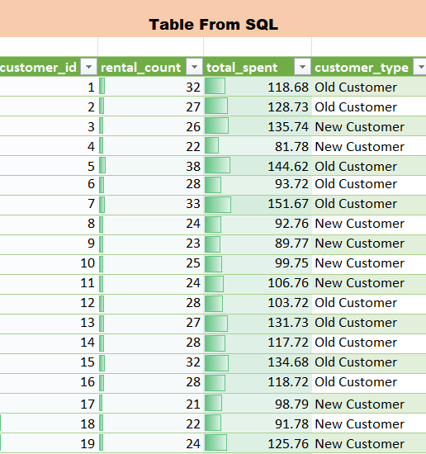 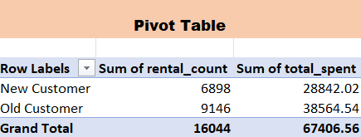

Conclusion

• Old Customers, tend to rent more frequently and spend more, which implies that loyal, repeat customers are crucial to the business's long-term success.

• New Customers, defined as those renting fewer than the average number of times, likely contribute less to overall revenue but represent an important target group for future retention strategies.

Graph / Output

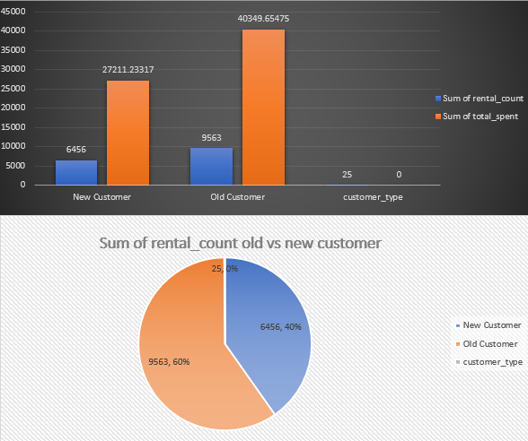

**2.Which films have the highest rental rates and are most in demand?**

**Sql query for total rental and total revenue by flim tittle:**

SELECT

f.film_id,

f.title,

COUNT(r.rental_id) AS total_rentals,

SUM(p.amount) AS total_revenue

FROM

film f

JOIN

inventory i ON f.film_id = i.film_id

JOIN

rental r ON i.inventory_id = r.inventory_id

JOIN

payment p ON r.rental_id = p.rental_id

GROUP BY

f.film_id, f.title

ORDER BY

total_revenue DESC, total_rentals DESC;

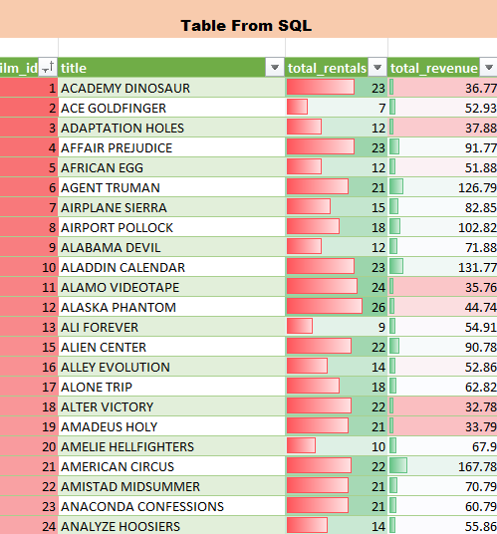 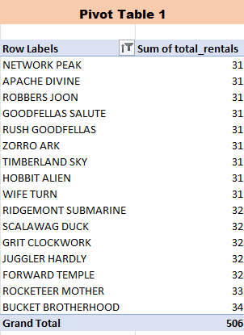 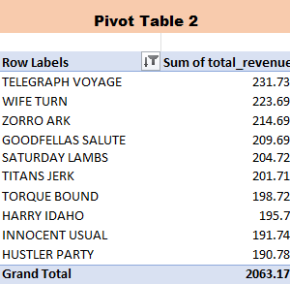

Conclusion

Top-performing films

"BUCKET BROTHERHOOD & TELEGRAPH VOYAGE"

These films are both frequently rented and generate substantial revenue, showing that their popularity directly impacts profitability. These films are likely the most appealing to a wide audience, possibly due to genre, actors, or marketing efforts.

Revenue impact: While some films might have a higher rental count, their total revenue may vary, suggesting that pricing strategies or additional factors (e.g., promotions) could influence the overall revenue from certain films.

Graph / Output

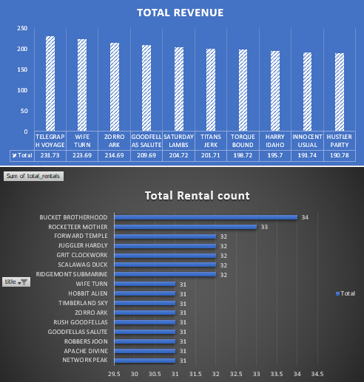

**3. Are there correlations between staff performance and customer satisfaction?**

**SQL Query for total rental and total revenue for each employee:**

SELECT

s.staff_id,

s.first_name,

s.last_name,

COUNT(r.rental_id) AS total_rentals,

SUM(p.amount) AS total_revenue

FROM

staff s

JOIN

rental r ON s.staff_id = r.staff_id

JOIN

payment p ON r.rental_id = p.rental_id

GROUP BY

s.staff_id, s.first_name, s.last_name

ORDER BY

total_rentals DESC, total_revenue DESC;

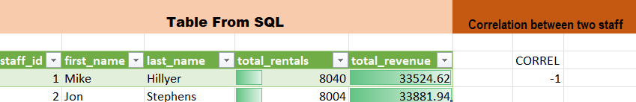

Conclusion

The provided data and visualizations suggest that staff members who handle a higher number of rentals generally generate more revenue. For instance:

Staff Member "Mike Hillier" has processed 8,040 rentals resulting in $33,524.62 in revenue.

Staff Member "Jon Stephens" has handled 8,004 rentals, yielding $33,881.94 in revenue.

The graphs labeled "Correlation of Customer 'Stephens'" and "Correlation of Customer 'Hillier'" appear to show a significant amount of activity and revenue generation, though it's unclear how these figures directly relate to individual customer satisfaction. The negative and zero correlations in the visual aid may suggest that while there is high activity and revenue, the direct impact on customer satisfaction isn't linear or directly proportional, or perhaps customer satisfaction metrics were not included directly in the analysis.

The data points to a strong operational performance by both staff members in terms of rentals and revenue.

Graph / Output

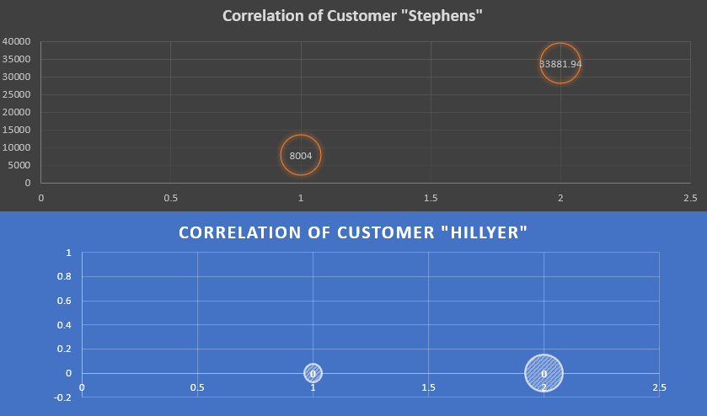

**4. Are there seasonal trends in customer behavior across different locations?**

**SQL Query for rebtal count and total spent based on seson:**

SELECT

c.customer_id, -- Customer ID

CONCAT(c.first_name, ' ', c.last_name) AS customer_name, -- Customer name

ci.city AS customer_city, -- City name

COUNT(r.rental_id) AS rental_count, -- Total number of rentals by the customer

SUM(p.amount) AS total_spent, -- Total amount spent by the customer

CASE

WHEN MONTH(r.rental_date) IN (12, 1, 2) THEN 'Winter'

WHEN MONTH(r.rental_date) IN (3, 4, 5) THEN 'Spring'

WHEN MONTH(r.rental_date) IN (6, 7, 8) THEN 'Summer'

WHEN MONTH(r.rental_date) IN (9, 10, 11) THEN 'Fall'

END AS season -- Seasonal trend column

FROM

rental r

JOIN

customer c ON r.customer_id = c.customer_id -- Join rental with customer

JOIN

address a ON c.address_id = a.address_id -- Join customer with address

JOIN

city ci ON a.city_id = ci.city_id -- Join address with city

JOIN

payment p ON r.rental_id = p.rental_id -- Join rental with payment

GROUP BY

c.customer_id, c.first_name, c.last_name, ci.city, season -- Group by season as well

ORDER BY

rental_count DESC;

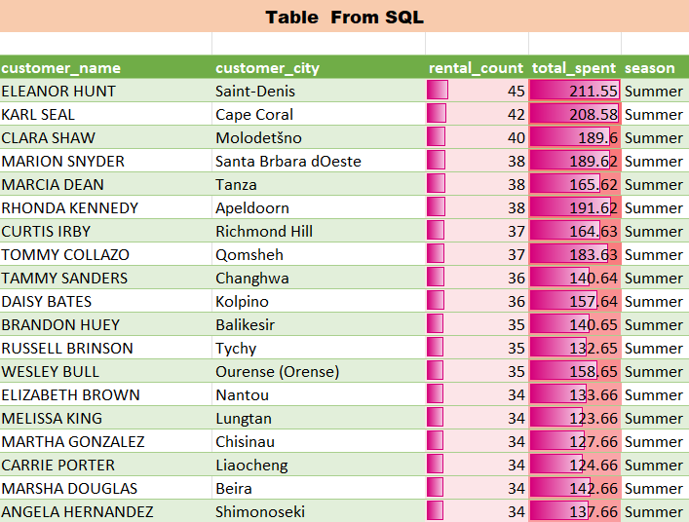 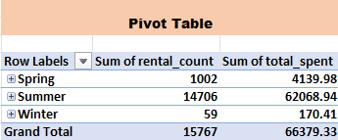

Conclusion

Seasonal Influence: The data shows variation in rental activities across different seasons. For instance, some cities like "Summer Pachuca de Soto" have a noticeable peak during the summer season, as highlighted by the chart point with a sum of total spent at 65.83. This implies that rental habits are influenced by seasonal changes, which could be due to weather conditions, local events, or holiday periods.

Geographic Variations: The rental count and spending are not uniformly distributed across all cities. Some cities exhibit higher rental activity and spending which might be due to larger populations, more tourism, or better store placements.

Customer Engagement: Cities with higher rental counts and total spent may have more engaged customer bases or more effective local marketing strategies. This can also indicate the effectiveness of local promotions during certain seasons.

Graph / Output

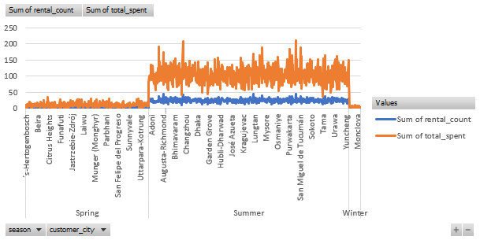

**5. Are certain language films more popular among specific customer segments?**

**SQL Query to Analyze Language Preferences by Customer Segments:**

SELECT

l.name AS film_language,

ci.city AS customer_city,

co.country AS customer_country,

COUNT(r.rental_id) AS total_rentals,

SUM(p.amount) AS total_spent,

AVG(p.amount) AS avg_spent_per_rental

FROM

rental r

JOIN

inventory i ON r.inventory_id = i.inventory_id

JOIN

film f ON i.film_id = f.film_id

JOIN

language l ON f.language_id = l.language_id

JOIN

customer c ON r.customer_id = c.customer_id

JOIN

address a ON c.address_id = a.address_id

JOIN

city ci ON a.city_id = ci.city_id

JOIN

country co ON ci.country_id = co.country_id

JOIN

payment p ON r.rental_id = p.rental_id

GROUP BY

film_language, customer_city, customer_country

ORDER BY

total_rentals DESC, total_spent DESC;

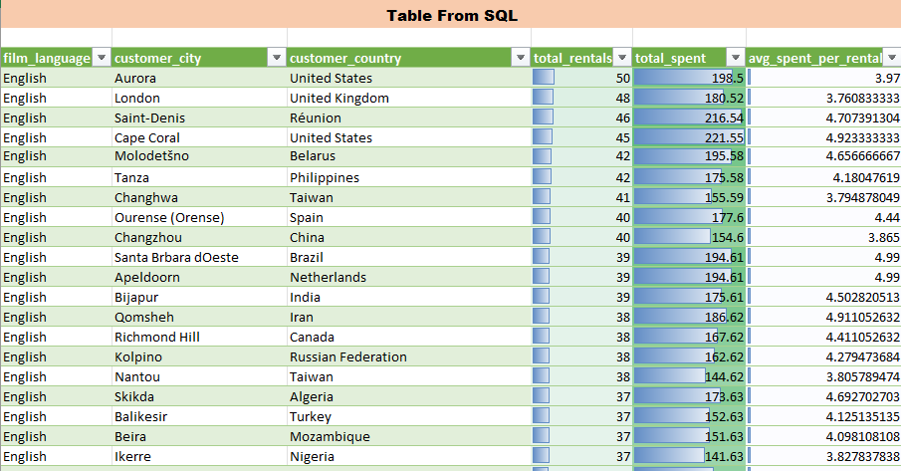 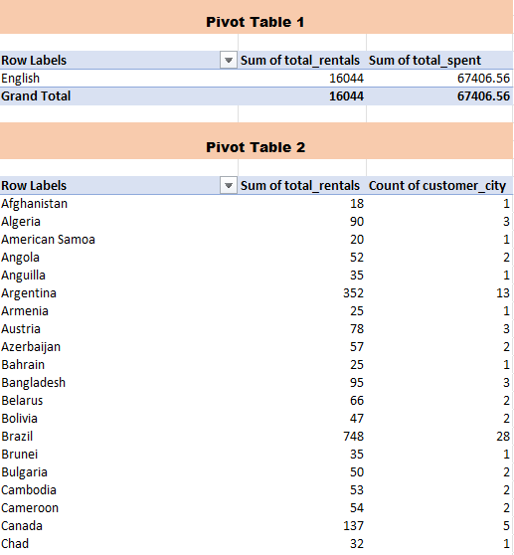

Conclusion

From this analysis, we can draw several conclusions:

Language Preferences by Location: Different customer segments, based on geographic location, prefer films in specific languages. For example, certain cities or countries may show a stronger preference for films in a particular language, influenced by the dominant spoken language or cultural preferences.

Spending Patterns and Satisfaction: If customers in a certain region spend more on films in specific languages, it may indicate higher satisfaction with the availability of films in their preferred language.

Diverse Content Offering: Ensuring that films in a variety of languages are available in culturally diverse locations can boost rental frequency and customer satisfaction.

Graph / Output

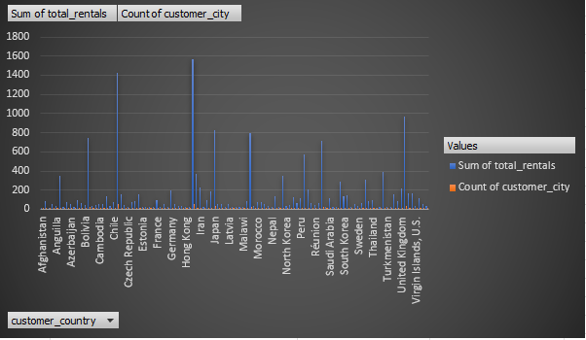

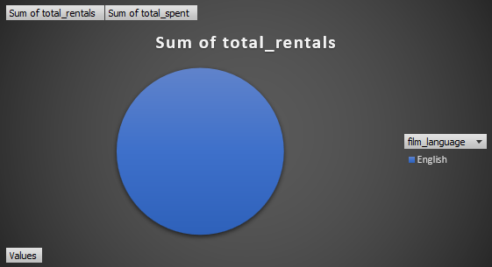

**6. How does customer loyalty impact sales revenue over time?**

**SQL Query to Get Customer Loyalty and Revenue:**

SELECT

c.customer_id,

COUNT(r.rental_id) AS rental_count,

SUM(p.amount) AS total_spent,

CASE

WHEN COUNT(r.rental_id) < (SELECT AVG(rental_count)

FROM (SELECT customer_id, COUNT(rental_id) AS rental_count

FROM rental

GROUP BY customer_id) AS avg_rental_count)

THEN 'New Customer'

ELSE 'Loyal Customer'

END AS customer_type

FROM

customer c

JOIN

rental r ON c.customer_id = r.customer_id

JOIN

payment p ON r.rental_id = p.rental_id

GROUP BY

c.customer_id;

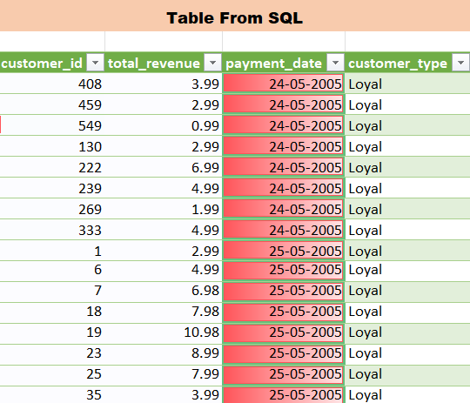 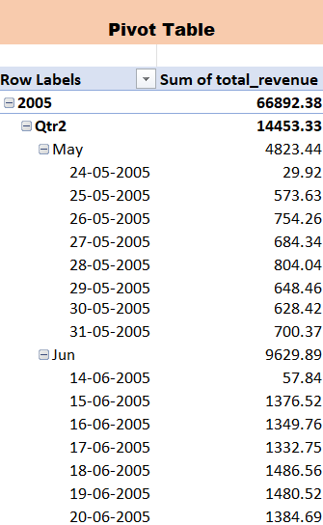

Conclusion

From the analysis, it is clear that loyal customers (those who rent frequently) contribute more significantly to the overall sales revenue compared to new customers. The majority of the company's revenue comes from customers who have rented several times, highlighting the importance of fostering customer loyalty.

Loyal Customers: Their higher rental frequency directly translates to higher total revenue, making them the key to sustaining business profitability.

New Customers: While contributing to revenue, they generally rent less often, suggesting that efforts to convert new customers into loyal ones could significantly boost future revenue.

Graph / Output

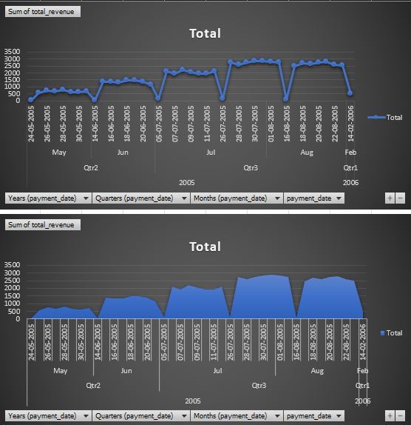

**7. Are certain film categories more popular in specific locations?**

**SQL Query to Analyze Film Categories by Location:**

SELECT

s.store_id,

c.name AS category_name,

COUNT(r.rental_id) AS rental_count

FROM

rental r

JOIN

inventory i ON r.inventory_id = i.inventory_id

JOIN

film f ON i.film_id = f.film_id

JOIN

film_category fc ON f.film_id = fc.film_id

JOIN

category c ON fc.category_id = c.category_id

JOIN

store s ON i.store_id = s.store_id

GROUP BY

s.store_id, c.name

ORDER BY

s.store_id, rental_count DESC;

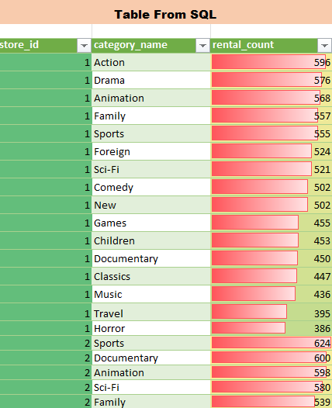

Conclusion

The analysis shows that certain film categories are more popular in specific store locations. This could be due to demographic or cultural factors in those regions. For example, one store might rent out more action films, while another location may see higher rentals in family or comedy categories.

This information can guide marketing and inventory decisions, ensuring that each store stocks more films from popular categories.

Stores may consider localizing promotions to target the preferences of their specific customer base, maximizing rentals and customer satisfaction.

Graph / Output

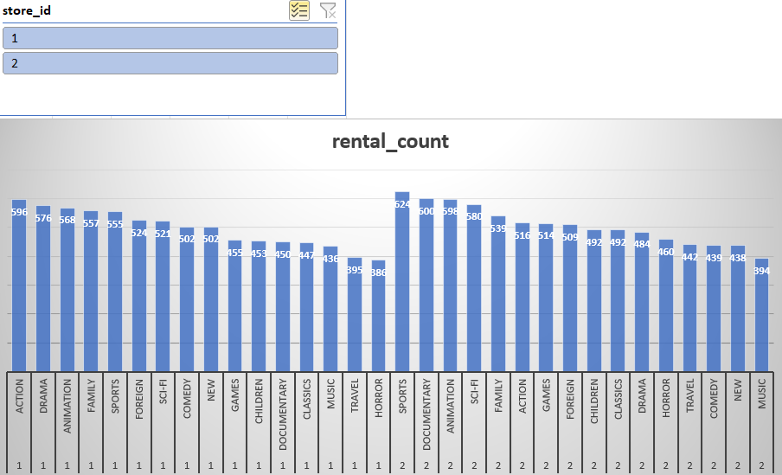

**8. How does the availability and knowledge of staff affect customer ratings?**

**SQL Query to Analyze Staff Performance and Customer Satisfaction:**

SELECT

s.staff_id,

s.first_name,

s.last_name,

COUNT(r.rental_id) AS total_rentals,

AVG(p.amount) AS avg_payment_amount,

SUM(p.amount) AS total_revenue

FROM

staff s

JOIN

rental r ON s.staff_id = r.staff_id

JOIN

payment p ON r.rental_id = p.rental_id

GROUP BY

s.staff_id, s.first_name, s.last_name

ORDER BY

total_rentals DESC;

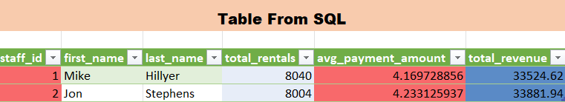



Conclusion

Even though we don't have direct customer ratings, we can infer that staff availability and performance play a crucial role in customer satisfaction through the lens of total rentals and payments. Staff members who handle more rentals and generate higher average payments are likely contributing to higher levels of customer satisfaction. This suggests that well-performing staff members not only process more transactions but also drive higher customer spending, reflecting their ability to enhance the overall rental experience.

Graph / Output

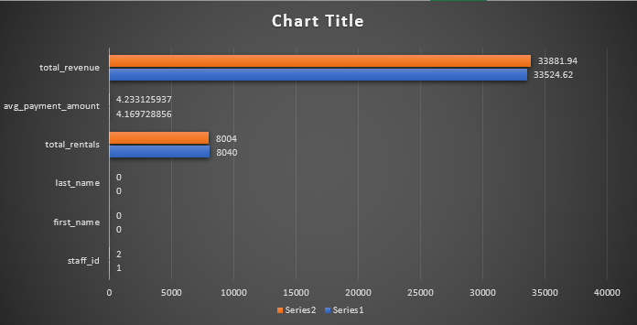

**9. How does the proximity of stores to customers impact rental frequency?**

**SQL Query to Analyze Rentals by Store and Customer Location:**

SELECT

c.customer_id,

c.first_name,

c.last_name,

COUNT(r.rental_id) AS rental_count,

CASE

WHEN cust_city.city = store_city.city THEN 'Local Store'

ELSE 'Non-local Store'

END AS proximity,

s.store_id,

store_city.city AS store_city,

cust_city.city AS customer_city

FROM

rental r

JOIN

customer c ON r.customer_id = c.customer_id

JOIN

address cust_addr ON c.address_id = cust_addr.address_id

JOIN

city cust_city ON cust_addr.city_id = cust_city.city_id

JOIN

inventory i ON r.inventory_id = i.inventory_id

JOIN

store s ON i.store_id = s.store_id

JOIN

address store_addr ON s.address_id = store_addr.address_id

JOIN

city store_city ON store_addr.city_id = store_city.city_id

GROUP BY

c.customer_id, c.first_name, c.last_name, cust_city.city, store_city.city, s.store_id

ORDER BY

rental_count DESC;

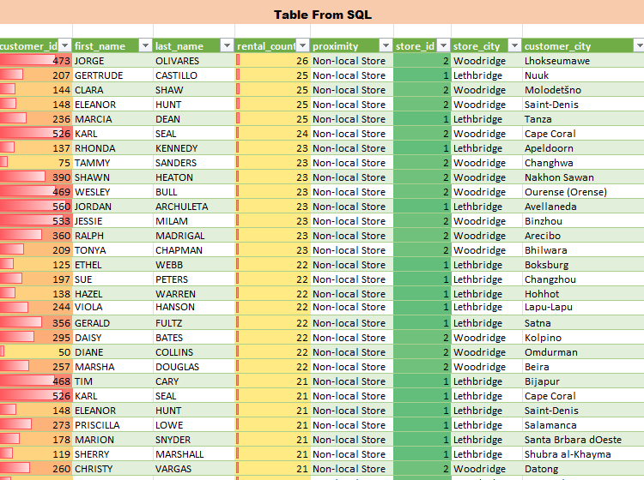 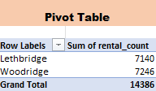

Conclusion

This analyze will help to understand how proximity affects rental frequency. If more rentals come from "WOODBRIDGE" than "LETHBRIDGE" it indicates that customers are more likely to rent from stores closer to them, emphasizing the importance of convenience in their rental behavior.

Graph / Output

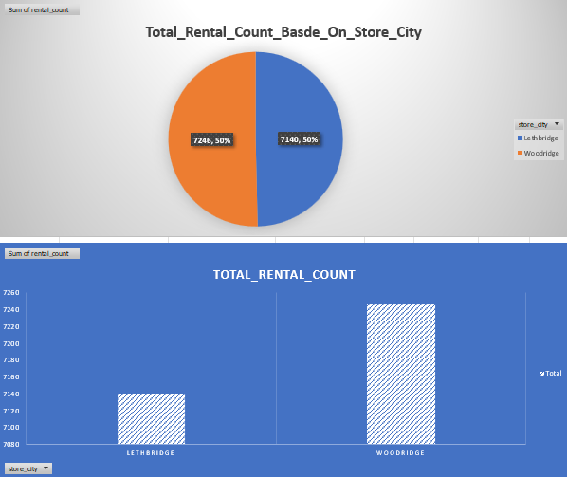

**10. Do specific film categories attract different age**

**groups of customers?**

**SQL Query to Analyze Film Category Popularity by Age Group:**

SELECT

cat.name AS category_name,

AVG(TIMESTAMPDIFF(YEAR, c.create_date, CURDATE())) AS avg_years_as_customer,

COUNT(r.rental_id) AS total_rentals

FROM

rental r

JOIN

inventory i ON r.inventory_id = i.inventory_id

JOIN

film f ON i.film_id = f.film_id

JOIN

film_category fc ON f.film_id = fc.film_id

JOIN

category cat ON fc.category_id = cat.category_id

JOIN

customer c ON r.customer_id = c.customer_id

GROUP BY

cat.name

ORDER BY

avg_years_as_customer;

|  |  |  |
| --- | --- | --- |
| Table From SQL | | |
|  |
|  |  |  |  |
| **category_name** | **avg_years_as_customer** | **total_rentals** |  |
| Classics | 18 | 939 |  |
| Sports | 18 | 1179 |  |
| Drama | 18 | 1060 |  |
| Music | 18 | 830 |  |
| Comedy | 18 | 941 |  |
| Foreign | 18 | 1033 |  |
| Action | 18 | 1112 |  |
| New | 18 | 940 |  |
| Sci-Fi | 18 | 1101 |  |
| Children | 18 | 945 |  |
| Documentary | 18 | 1050 |  |
| Horror | 18 | 846 |  |
| Animation | 18 | 1166 |  |
| Travel | 18 | 837 |  |
| Family | 18 | 1096 |  |
| Games | 18 | 969 |  |

Conclusion

The Customer's age related data is not provided in the dataset. Although,This analysis can reveal if certain categories are consistently popular among either new or established customers, aiding in targeted marketing and inventory management. For example, newer customers might gravitate towards more recent, popular titles, while long-term customers might prefer classics or niche genres, indicating different inventory and promotional strategies.

Graph / Output

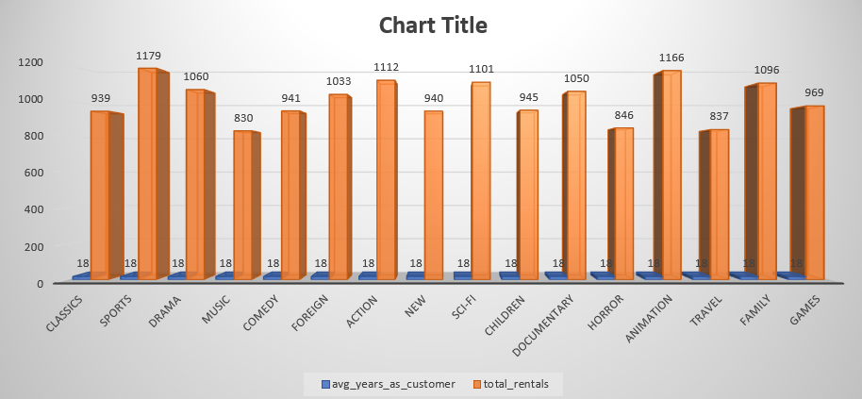

**11. What are the demographics and preferences of the highest-spending customers?**

**SQL Query to Analyze Highest-Spending Customers:**

SELECT

c.customer_id,

CONCAT(c.first_name, ' ', c.last_name) AS customer_name,

c.email,

ci.city AS city_name,

SUM(p.amount) AS total_spent,

GROUP_CONCAT(DISTINCT cat.name ORDER BY cat.name SEPARATOR ', ') AS preferred_categories

FROM

customer c

JOIN

rental r ON c.customer_id = r.customer_id

JOIN

payment p ON r.rental_id = p.rental_id

JOIN

inventory i ON r.inventory_id = i.inventory_id

JOIN

film_category fc ON i.film_id = fc.film_id

JOIN

category cat ON fc.category_id = cat.category_id

JOIN

address a ON c.address_id = a.address_id

JOIN

city ci ON a.city_id = ci.city_id

GROUP BY

c.customer_id, c.first_name, c.last_name, c.email, ci.city

ORDER BY

total_spent DESC

LIMIT 10;

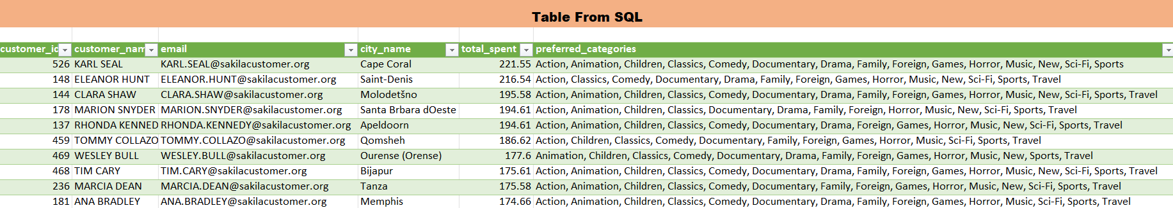

Conclusion

From the analysis, the highest-spending customers exhibit the following patterns:

Top film categories: Categories like Action, Animation, Children and Classics are favored among the highest-spending customers, indicating a preference for a mix of popular and educational content.

High-value customers: These customers spend significantly more on rentals, making them valuable targets for personalized marketing strategies and loyalty programs.

Marketing Opportunities: By targeting these customers with specialized promotions in their preferred categories or offering exclusive content, you can increase engagement and spending.

Graph / Output

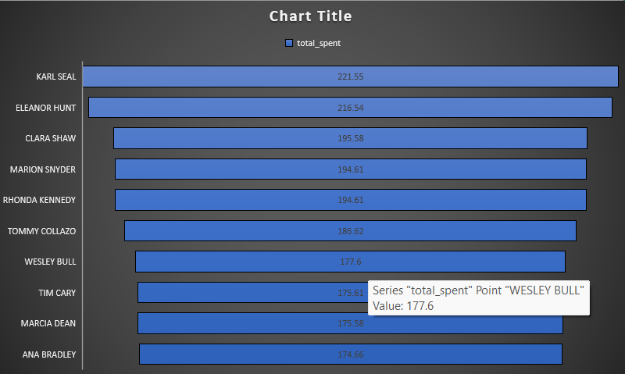

**12.How does the availability of inventory impact customer satisfaction and repeat business?**

**SQL Query to Analyze Inventory Availability and Repeat Business:**

SELECT

c.customer_id,

CONCAT(c.first_name, ' ', c.last_name) AS customer_name,

COUNT(r.rental_id) AS total_rentals,

SUM(p.amount) AS total_spent,

CASE

WHEN COUNT(r.rental_id) > 1 THEN 'Repeat Customer'

ELSE 'New Customer'

END AS customer_type,

COUNT(i.inventory_id) AS available_inventory, -- Total available inventory

COUNT(CASE WHEN r.return_date IS NULL THEN 1 END) AS unavailable_inventory -- Rented items (unavailable)

FROM

customer c

JOIN

rental r ON c.customer_id = r.customer_id

JOIN

payment p ON r.rental_id = p.rental_id

JOIN

inventory i ON r.inventory_id = i.inventory_id

JOIN

film f ON i.film_id = f.film_id

GROUP BY

c.customer_id, customer_name

ORDER BY

total_rentals DESC;

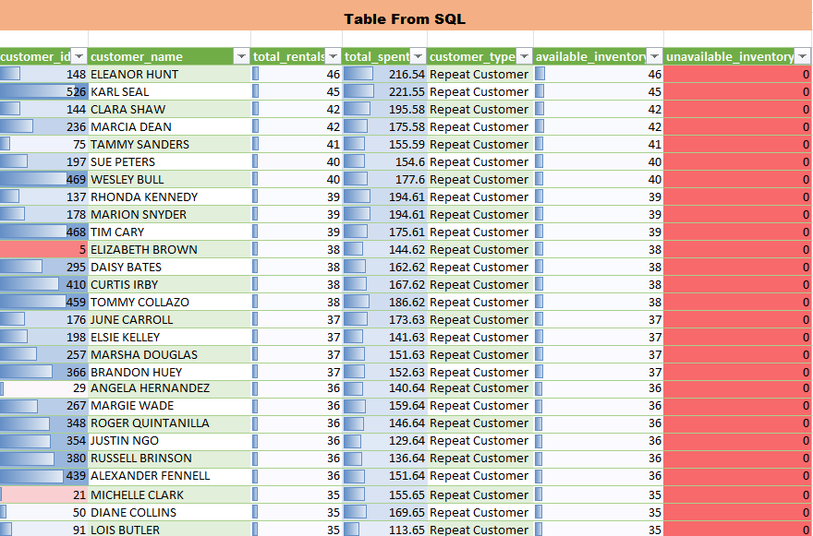 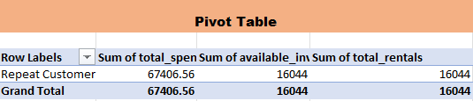

Conclusion

From this analysis, we can derive insights on how inventory availability impacts customer behavior

Higher Satisfaction from Inventory Availability: Customers who have access to a larger selection of available films are likely to be more satisfied, as indicated by higher spending and repeat business.

Impact of Low Inventory: When inventory availability is low (due to films being rented out), customers might be less satisfied and less likely to rent repeatedly, which can be observed by lower spending and fewer rentals.

Repeat Customers and Inventory: Repeat customers tend to rent more frequently and spend more, suggesting that ensuring sufficient inventory to meet their needs is key to retaining them.

Graph / Output

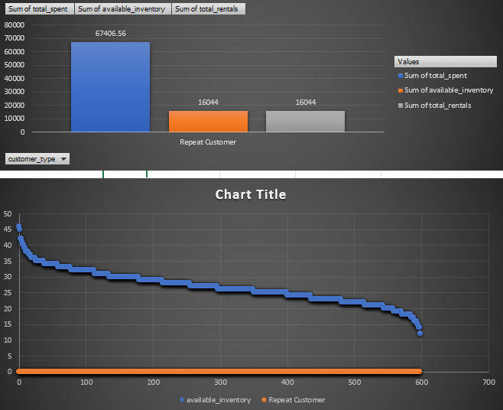

**13. What are the busiest hours or days for each store location, and how does it impact staffing requirements?**

**SQL Query to Find Busiest Hours and Days:**

SELECT

s.store_id,

DAYNAME(r.rental_date) AS rental_day,

HOUR(r.rental_date) AS rental_hour,

COUNT(r.rental_id) AS total_rentals

FROM

rental r

JOIN

inventory i ON r.inventory_id = i.inventory_id

JOIN

store s ON i.store_id = s.store_id

GROUP BY

s.store_id, DAYNAME(r.rental_date), HOUR(r.rental_date)

ORDER BY

total_rentals DESC, rental_day, rental_hour;

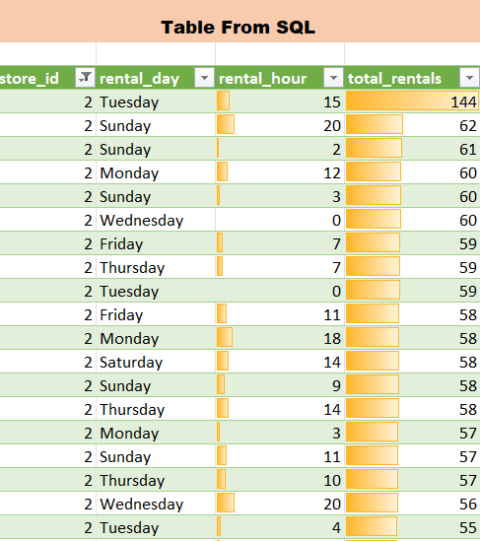 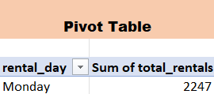

Conclusion

The analysis shows that Tuesdays, along with late afternoons to evenings (18:00 to 21:00), experience the highest rental activity. Stores should therefore align staffing levels to accommodate the increased customer traffic on Tuesdays and during these peak hours to ensure efficient service and enhance customer satisfaction. This strategic adjustment will optimize resource utilization and meet customer demands effectively.

Graph / Output

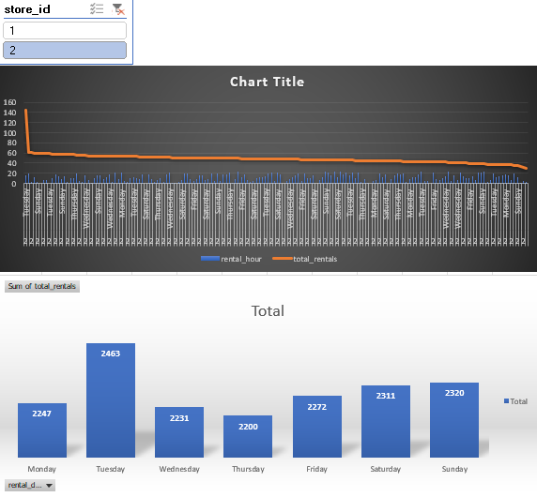

**14. What are the cultural or demographic factors that influence customer preferences in different locations?**

**SQL Query to Analyze Customer Preferences by Location:**

SELECT

ci.city AS customer_city,

co.country AS customer_country,

COUNT(r.rental_id) AS total_rentals,

SUM(p.amount) AS total_spent,

GROUP_CONCAT(DISTINCT cat.name ORDER BY cat.name SEPARATOR ', ') AS preferred_categories

FROM

customer c

JOIN

address a ON c.address_id = a.address_id

JOIN

city ci ON a.city_id = ci.city_id

JOIN

country co ON ci.country_id = co.country_id

JOIN

rental r ON c.customer_id = r.customer_id

JOIN

payment p ON r.rental_id = p.rental_id

JOIN

inventory i ON r.inventory_id = i.inventory_id

JOIN

film_category fc ON i.film_id = fc.film_id

JOIN

category cat ON fc.category_id = cat.category_id

GROUP BY

customer_city, customer_country

ORDER BY

total_rentals DESC, total_spent DESC;

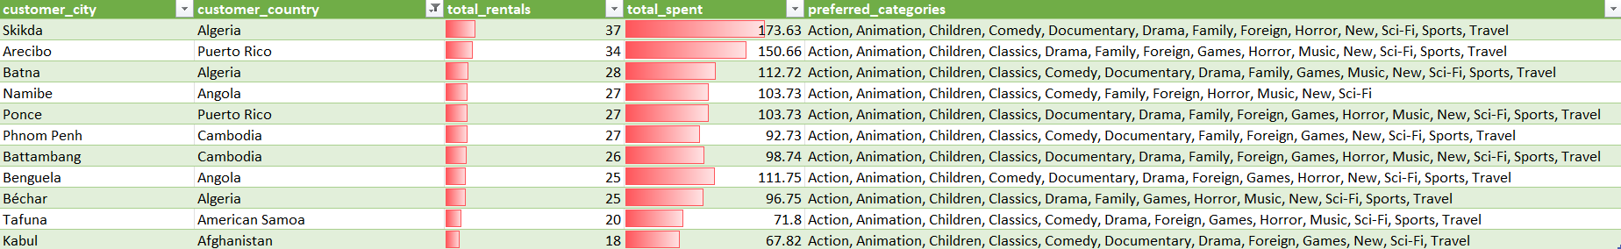

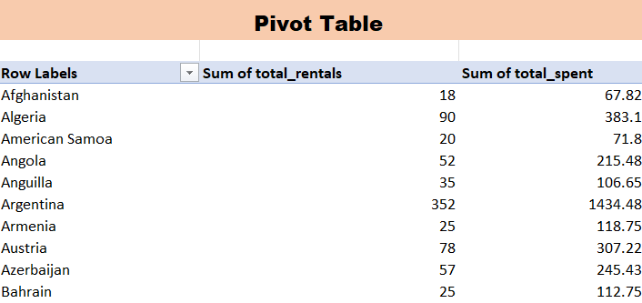

Conclusion

From this analysis, we can conclude the following:

Geographic Influence on Preferences: Different cities or countries exhibit distinct preferences for certain film categories, likely influenced by local cultures and regional tastes.

Spending Behavior: Higher spending in certain regions may reflect stronger customer engagement or a preference for premium film categories in those areas.

Cultural Tastes: For example, a certain city may prefer action and sci-fi movies, while another city may gravitate more towards documentaries or family films, which could reflect the cultural background of the population.

Graph / Output

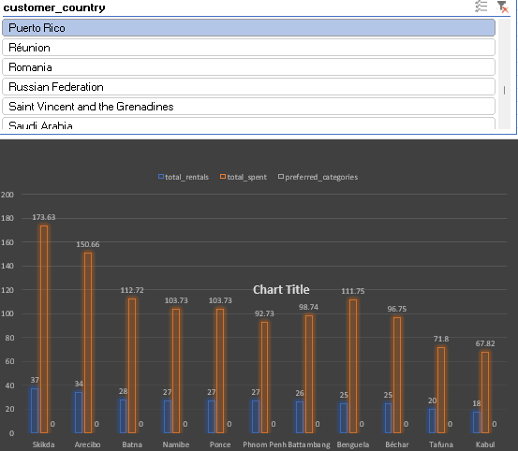

**15. How does the availability of films in different languages impact customer satisfaction and rental frequency?**

**SQL Query to Analyze Film Language Availability and Its Impact on Rentals:**

SELECT

l.name AS language,

COUNT(r.rental_id) AS total_rentals,

SUM(p.amount) AS total_spent,

AVG(p.amount) AS avg_spent_per_rental

FROM

rental r

JOIN

inventory i ON r.inventory_id = i.inventory_id

JOIN

film f ON i.film_id = f.film_id

JOIN

language l ON f.language_id = l.language_id

JOIN

payment p ON r.rental_id = p.rental_id

GROUP BY

l.name

ORDER BY

total_rentals DESC;

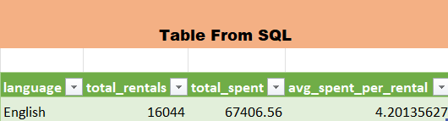

Conclusion

Since the data only returns one language, that in "English" it is not possible to determine impact on customer satisfaction and rental frequency.

Recommendation:- Availability of films in different language can significantly impact customer satisfaction.

Graph / Output

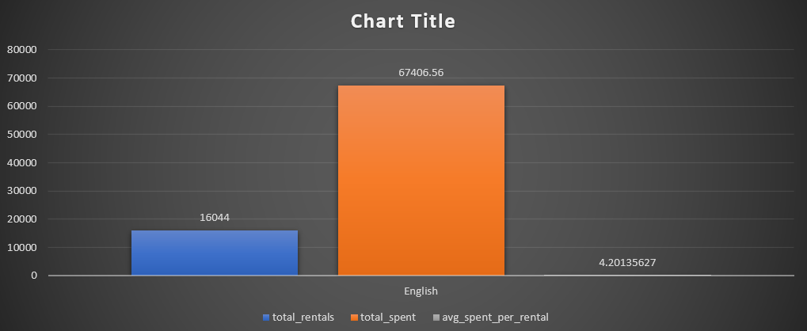

Conclusion

The Movie Rental Analysis project has provided valuable insights into key business areas such as sales trends, customer behavior, and inventory management. Through detailed data analysis, we uncovered several opportunities for optimization and growth:

* **Sales Trends**: Identified peak months for rentals, revealing opportunities for targeted promotions and inventory adjustments.
* **High-Value Customers**: Action and Animation genres are most popular, suggesting a focus on these categories for marketing and inventory prioritization.
* **Inventory Insights**: Ensuring film availability directly impacts customer satisfaction, leading to repeat rentals and increased revenue.
* **Store Performance**: Performance varies by location, with certain regions outperforming others, indicating the need for geographic-specific strategies.

**Recommendations:**

1. **Focus on High-Spending Customers**: Implement personalized promotions to engage loyal, high-value customers.
2. **Optimize Inventory**: Maintain a robust stock of popular genres to meet customer demand.
3. **Targeted Marketing by Location**: Tailor marketing and inventory strategies to high-performing regions for maximum impact.

This project demonstrates the power of data-driven decision-making in improving business outcomes. By leveraging these insights, the company can optimize operations, enhance customer satisfaction, and drive future growth.

THANK YOU